Forward Chaining
AIM:
To write a Prolog program to implement forward chaining and derive new facts from existing facts and rules.
ALGORITHMS:

  - Start.
  - Initialize the knowledge base with known facts.
  - Define inference rules containing conditions and conclusions.
  - Check each rule to determine whether its conditions are satisfied by the known facts.
  - If a rule is satisfied and its conclusion is not already known, add the conclusion to the knowledge base.
  - Repeat the rule-checking process until no new facts can be derived.
  - Display all the facts obtained through inference.
  - Stop.

CODE:
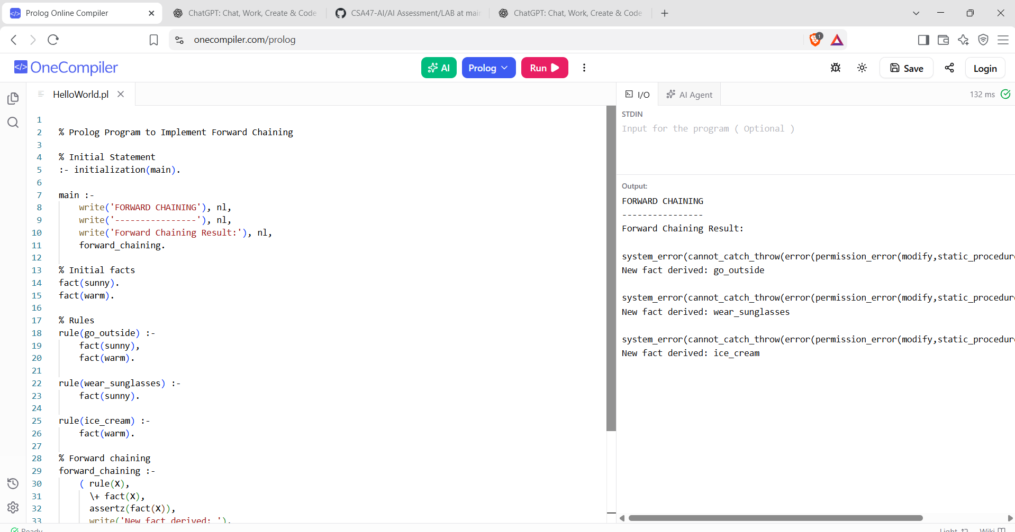

RESULTS:
The program derives new facts from existing facts and rules until no further conclusions can be obtained.

